**Using the Quick Search Tool**

**STEP 1:** Log in to the Worker Portal using the link below.

<https://kog.chfs.ky.gov/home/>

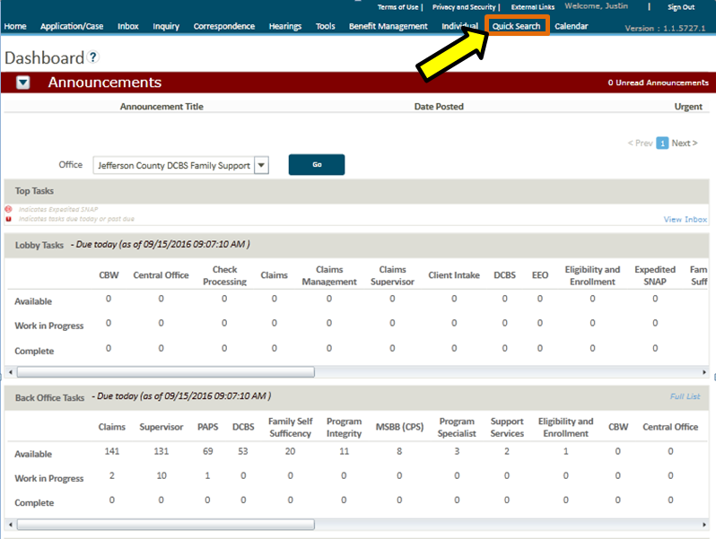

**Step 1**

Once you have logged into Worker Portal you will land on the Dashboard Screen. This screen displays the Top 10 tasks (if any) available to you as a user.

* To look up a case or individual select **Quick Search** from the top menu as indicated in the screen shot.

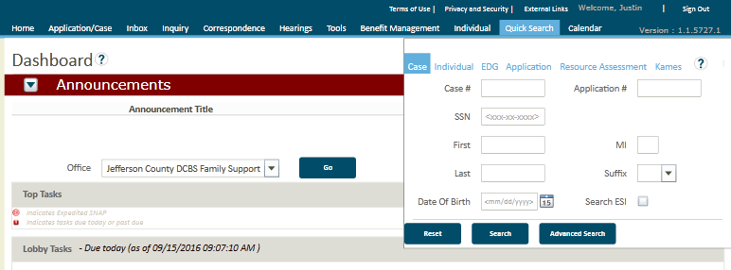

**Step 3**

A small search box will populate beneath the Quick Search Menu

You can search for Cases, Individuals, and a variety of other methods by clicking the blue labels identified by the red box and entering the data in the fields indicated by the yellow box.

**NOTE**: Additional search criteria including County, phone number, email address, and other criteria are available by clicking on the Advanced Search Button indicated by the green box**.**

**Step 4:**

Click the **Accept** button

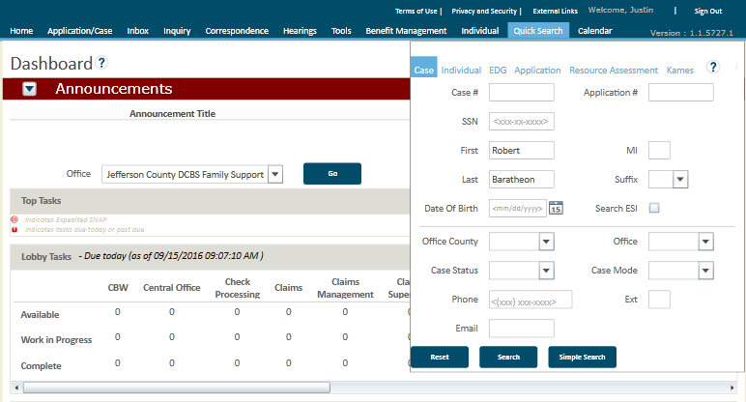

**Step 4 - Case Search**

Once you have entered your search criteria, select the **Search Button** as indicated in the screen shot.

1. 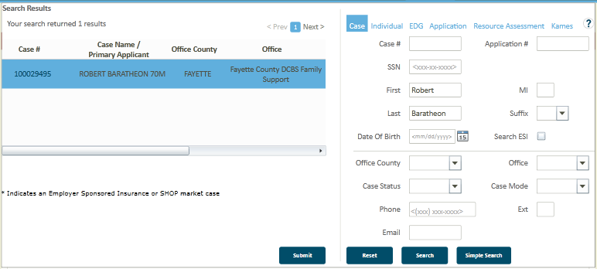

**Step 5 – Case Search**

The results of the search will appear in the box to the left of the **Quick Search Tool** as shown. To access the search results you can either:

1. Highlight the entire row by clicking on the **Case Name** and selecting **Submit** as indicated in Screenshot 1.

**-or-**

1. Clicking the **Case #** hyperlink where indicated in Screenshot 2.

Either action will bring you to the case summary screen for the selected record.

1. 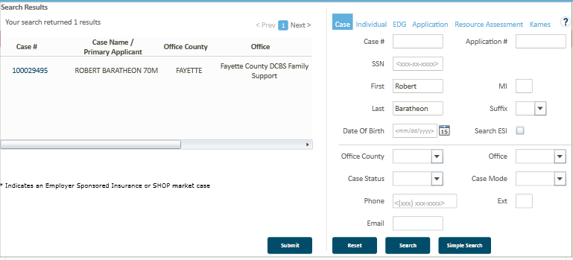

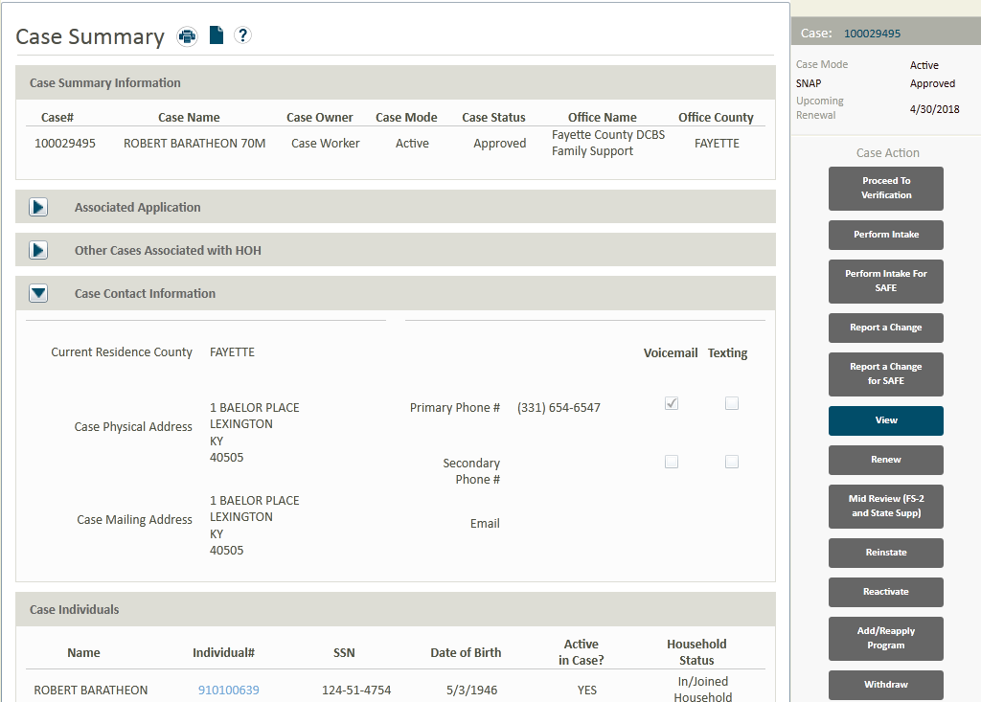

**Step 6 – Case Summary Screen**

The **Case Summary Screen** provides a summary of the information for the case you have selected including, but not limited to:

* Current address & contact information
* Associated case

individuals including DOB and SSN.

* Authorized Representatives
* Case Actions Dates, Eligibility Determination Groups, & Dates of reviews
* Issued benefits
* Medicaid and Health Insurance enrollments (if receiving through Benefind)

